Install the Automation Anywhere plug-in for Citrix only on machines where both Citrix Receiver and Enterprise client or Bot agent are installed.

**Prerequisites**

**Note:** Install the Citrix Receiver before you install the Enterprise client or Bot agent.

If you installed Enterprise client or Bot agent before the Citrix Receiver:

1. Uninstall Enterprise client or Bot agent.
2. Install the Citrix Receiver and verify the Automation.CitrixDriver.dll is in the *<Citrix installation path>*\Citrix\ICA Client folder. For example:

C:\Program Files (x86)\Citrix\ICA Client

1. Logoff from the Citrix web and log back in.
2. Reinstall the Enterprise client or Bot agent.

**Note:**

This content applies to Automation Anywhere Enterprise both Version 11.3.2 or later and Version A2019 or later.

* If you are using Version 11.3.2 or later, the local machine installed component is Enterprise client.
* If you are using Version A2019, the local machine installed component is Bot agent.

**Procedure**

1. From the Windows machine, open a command prompt as Administrator.
2. Change the directory to the location where the Enterprise client is installed.

For example, if the client is installed at the location C:\Program Files(x86)\Automation Anywhere\Enterprise\Client, run the command:

cd "C:\Program Files(x86)\Automation Anywhere\Enterprise\Client"

The quotes are required around the specified path because there are space characters in the pathname.

1. Run the plug-in installation command.

AAPluginInstallation.exe /citrix /install.

A success message appears after successful installation of the Automation Anywhere plug-in for Citrix.

1. On the **Automation Anywhere Enterprise Client** dialog box, click **OK**.
2. Version 11.3.2 Modify the AA.Settings.xml file:
   1. From the Enterprise client, select **Tools** > **Options** to find the location of the file.
   2. Click **Advanced Settings**.
   3. Open the AA.Settings.xml file from the location shown in the **Application Path** field.
   4. Add the <isremoteobjectdetectionenabled> and <citrixchanneltimeout> tags.

Set <isremoteobjectdetectionenabled> to true

Set <citrixchanneltimeout> required value. The Citrix session timeout value is in milliseconds.

For example:

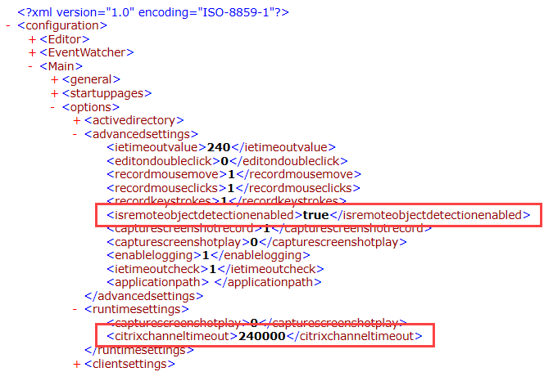

1. Save and close the file.